DS Project Phase (1)



|  |  |  |
| --- | --- | --- |
| Submitted by: | Section | ID |
| احمد السيد علي احمد | 1 | 17E0121 |
| احمد خالد محمد عفيفي | 1 | 1700065 |
| مريم محمد علاء الدين | 4 | 1701406 |
| هاجر وليد سليمان | 5 | 1701623 |
| هدير عفت عبدالعزيز | 5 | 1701641 |
| ياسمين عبد العزيز عبد الغني طه حمزة | 5 | 1701676 |

CAIRo, Egypt

December 10,2021

* Table of contents:   
   🡪 Introduction  
   🡪 Target Beneficiaries of the project  
   🡪 Adopted Programming Language  
   🡪 System Architecture  
   🡪 Application-Level Protocol  
   🡪 Distributed Database Design  
   🡪 Time Plan  
   🡪 Testing  
   🡪 End-User Guide   
   🡪 Resources Needed  
   🡪 Role of Each member  
   🡪 Appendices  
   🡪 References
* Introduction:  
   The designed distributed marketplace system is a website called “The Outlet”. The website provides common E-commerce functionalities such as the following :  
   🡺 Browsing online for products according to categories and searching for items  
  🡺 Easy Login / Registration properties on the website   
  🡺 Adding / Editing cart items, checking out and purchasing  
  🡺 Easy checkout with multiple payment options (Credit card of using your online wallet)  
  🡺 Displaying items to sell and managing inventory of items   
  🡺 Depositing cash into online wallet  
  🡺 Viewing profile information  
  🡺 Viewing Purchases History  
  *The website has Distributed database where the tables are partitioned*
* Target Beneficiaries of the project:  
   Online Shopping has significantly increased the past few years, especially with COVID-19 rising. It provides a safer, much faster, and more organized shopping experience.  
  Moreover, clients can purchase anytime of the day and from anywhere.  
  It’s also beneficial to stores’ owners as it provides more reach to much more clients. Therefore, increasing the stores’ sales. Also, it means low operational expenses, better nature of administrations and no need of physical organization set-ups.  
  For Startup stores, it’s found to be easier to construct an online store and start selling right away as it decreases initial capital investment, expenditure and resources needed.  
  In conclusion, Online shopping is seen to be the future for multiple reasons, with a lot of people in benefit from it.
* Adopted Programming Language:   
   🡺 HTML   
   🡺 CSS  
   🡺 PHP  
   🡺 Laravel

System Architecture:   
 🡺 We use a 3-tier system in our project, and they are: User - Server - Database   
 -The first tire is the user who requests services from the server   
 -The second is the server who check the validation of the user’s request   
 -The final tire is distributed Database stores all the data of user’s info and   
 product info

* Application-Level Protocol:

* 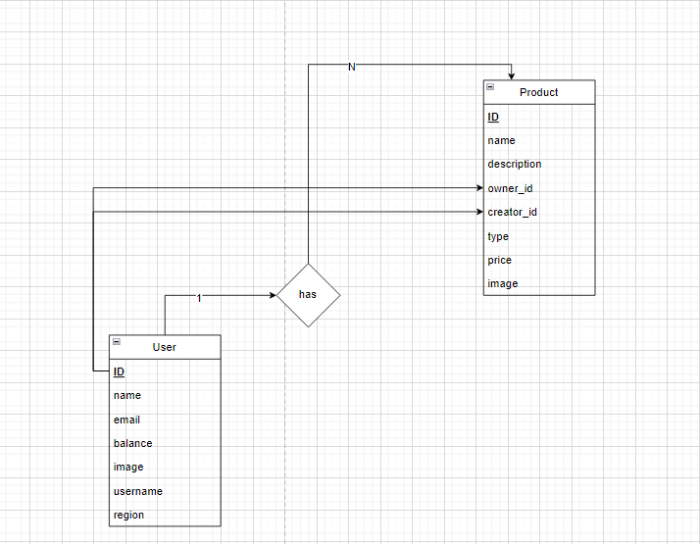Distributed Database Design:   
   🡺 One user has many products  
   🡺 Many products belong to one user   
   🡺 creator_id and owner_id in product table reference to id in user table
* 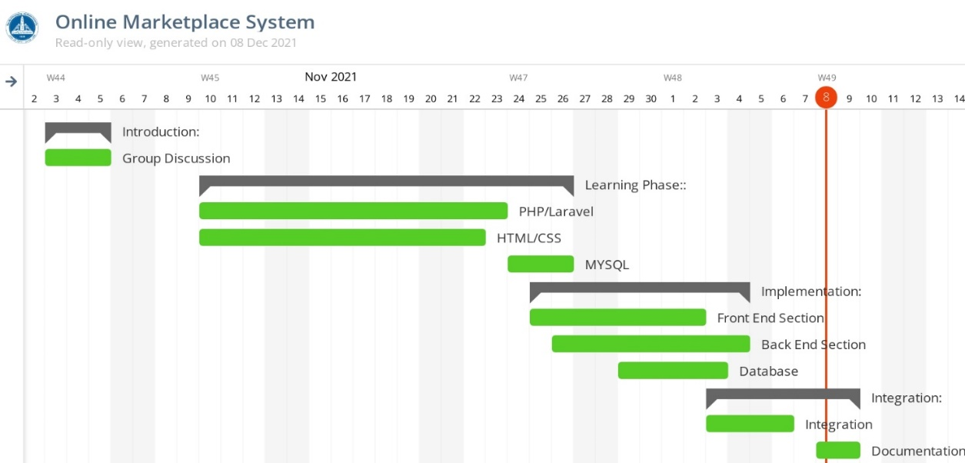Time Plan:
* 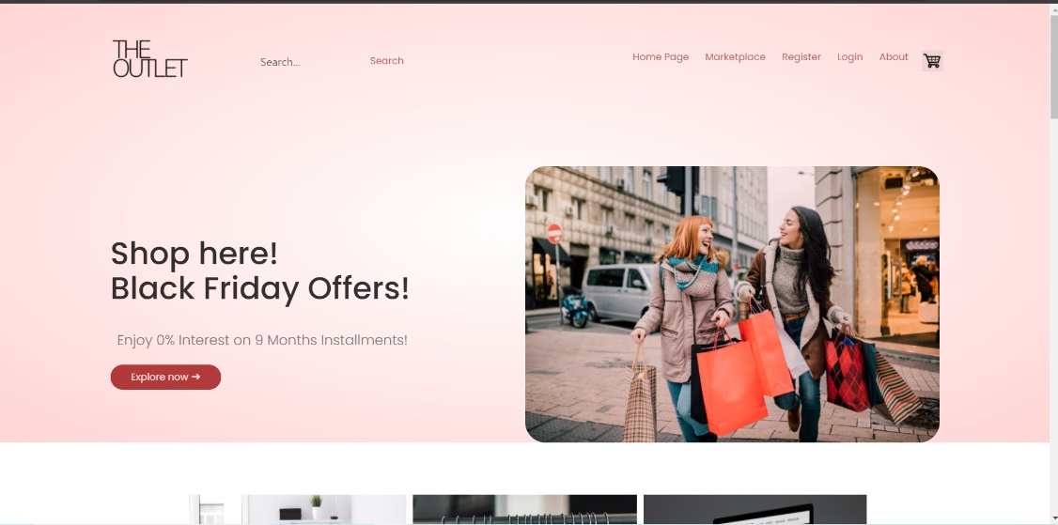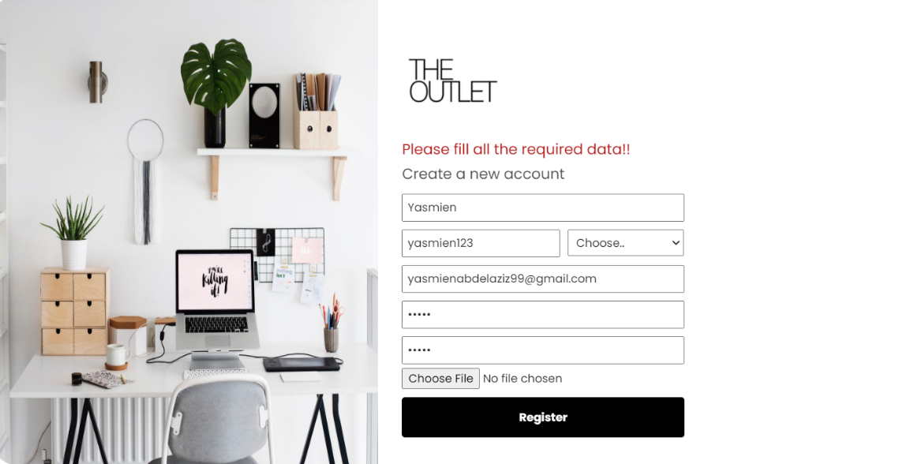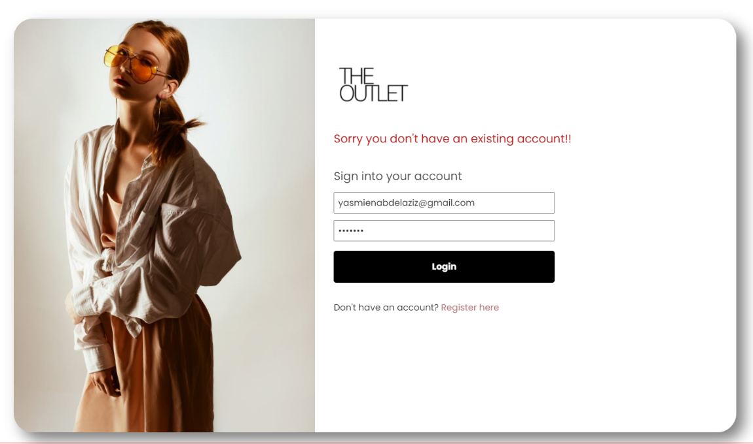Testing:   
   🡺How the main page appears to the users that don’t have an account:  
    
     
    
     
    
    
    
    
    
    
    
    
    
    
    
    
   🡺When someone tries to login without having an account:  
    
    
    
    
    
    
    
    
    
    
    
    
    
    
    
    
    
    
   🡺When he tries to create an account and forgot to insert some needed data:   
    
    
    
    
    
    
    
    
    
    
    
    
    
    
  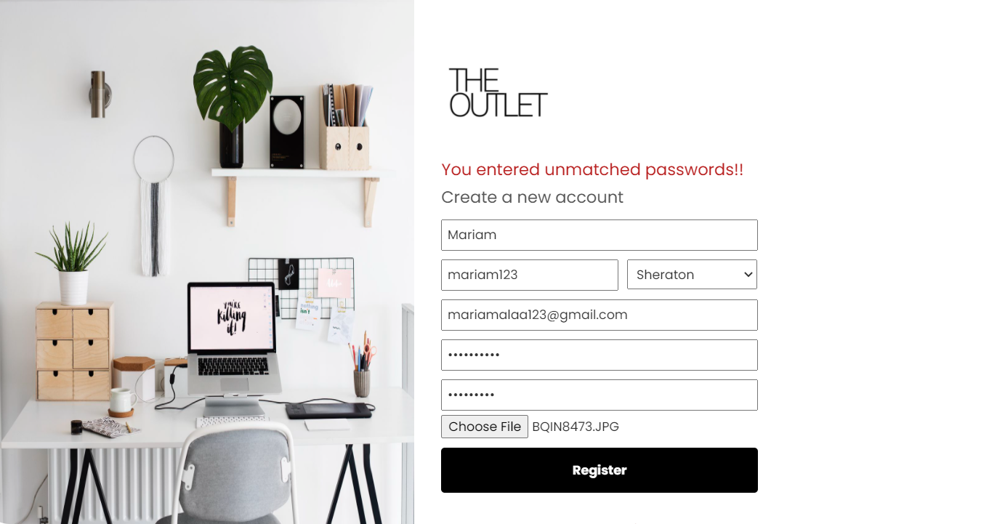 🡺 If the user entered unmatched passwords:  
    
    
    
    
    
    
    
    
    
    
    
    
    
    
    
    
  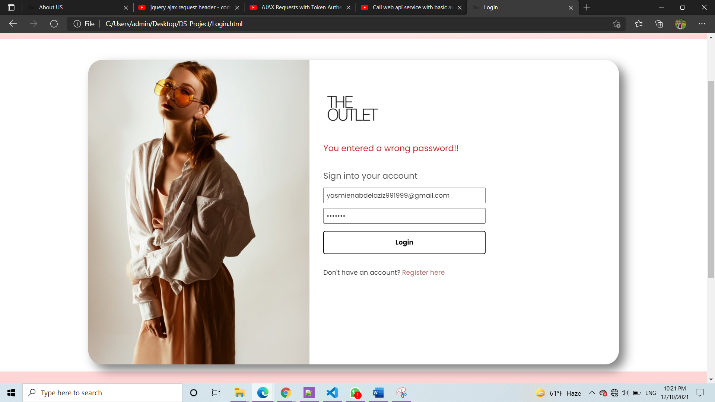 🡺When the user enters a wrong password:   
    
    
    
    
    
    
    
    
    
    
    
    
    
    
    
    
    
    
   🡺 How the main page appears to the users that are having an account:  
  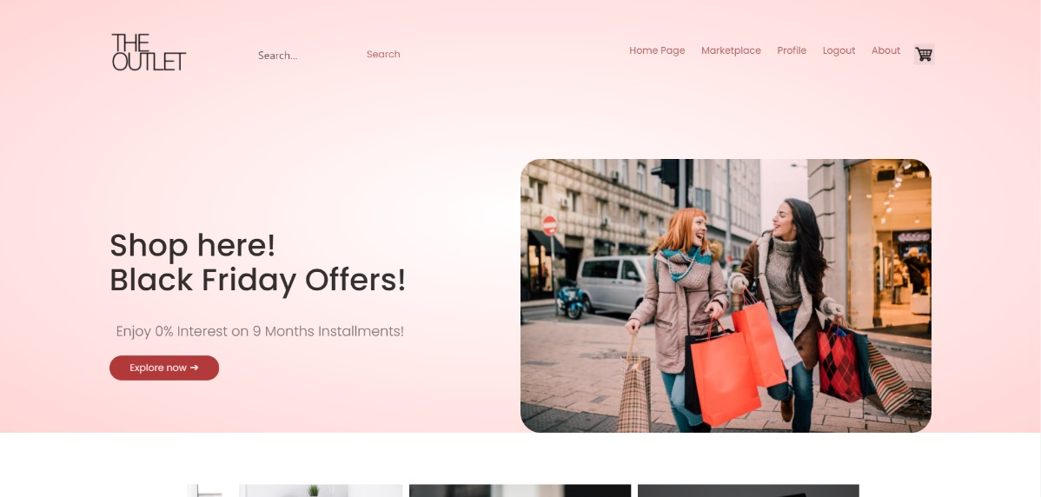

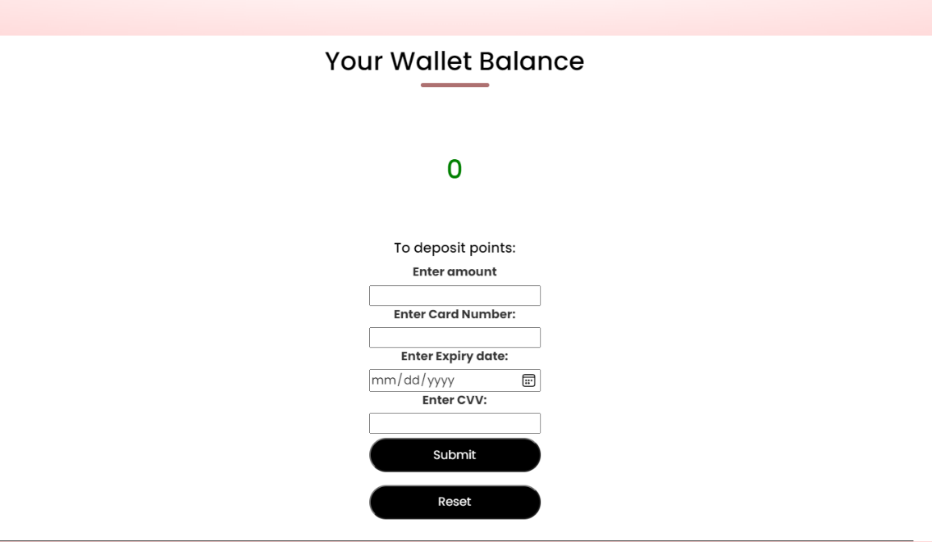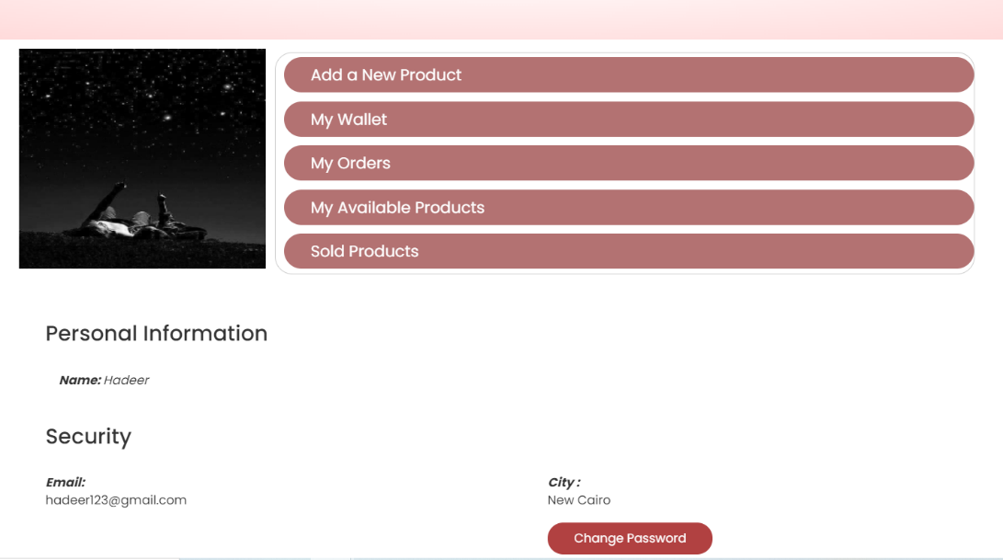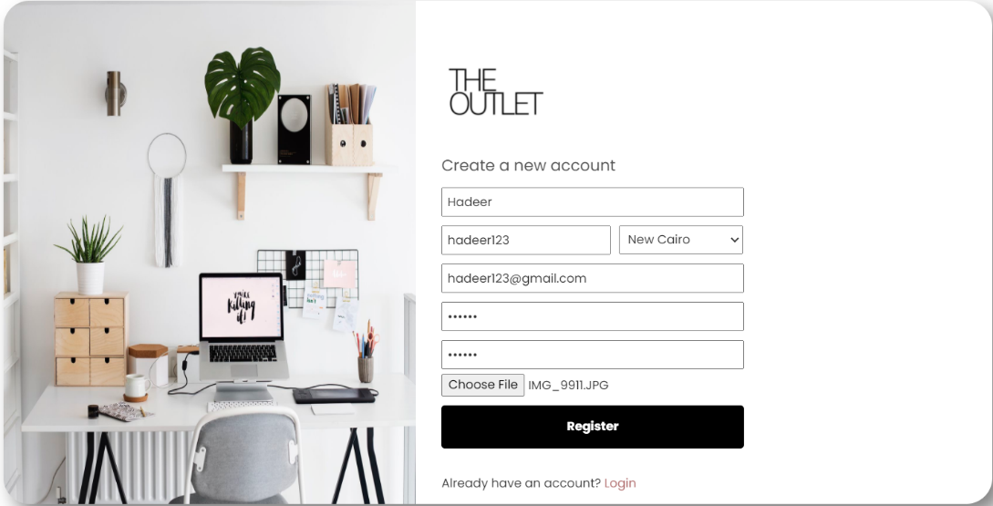🡺 Creating a new account:  
- Registration:  
  
  
  
  
  
  
  
  
  
  
  
  
  
  
  
-Profile of The New User:  
  
  
  
  
  
  
  
  
  
  
  
  
  
  
  
  
-Wallet of the new user:  
  
  
  
  
  
  
  
  
  
  
  
  
  
  
  
  
  
  
  
- Orders of the new user:   
  
  
  
  
  
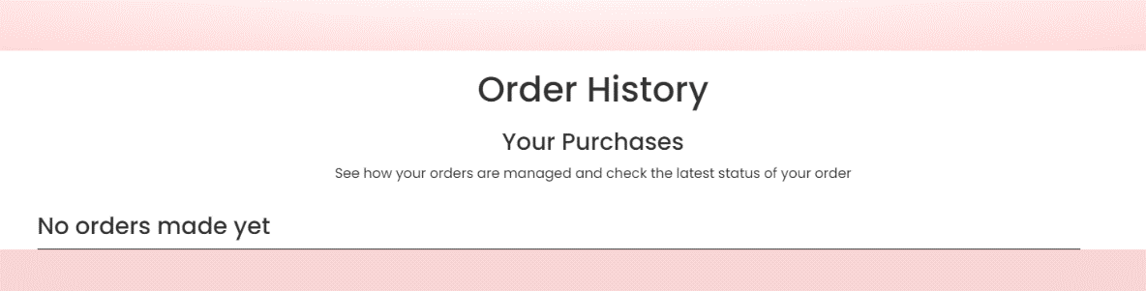  
-Available items from the new user’s market:  
  
  
  
  
🡺 Creating a new post:  
-Product details page:  
  
  
  
  
  
  
  
  
-My Available products after adding one product:  
button:  
  
  
  
  
  
  
  
  
  
  
  
  
  
  
  
  
  
  
  
  
-After changing the password this window appears:  
  
  
  
🡺 Searching for a product:  
- Searching for Mi band:

* 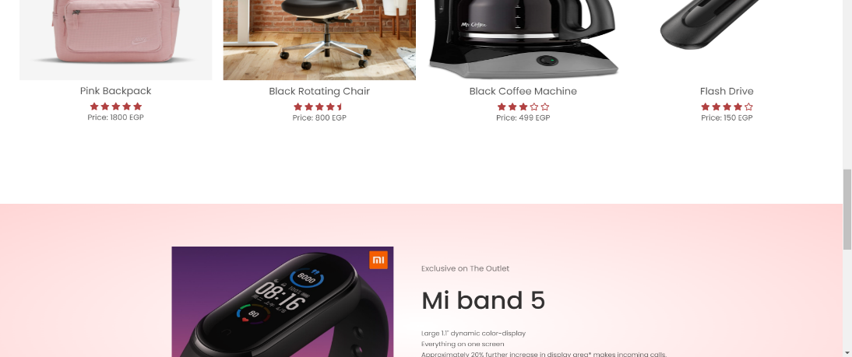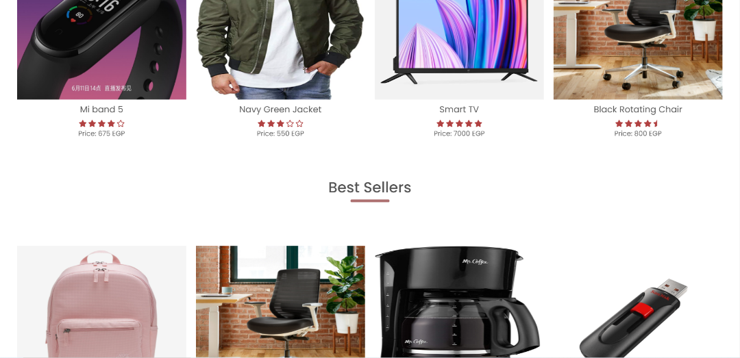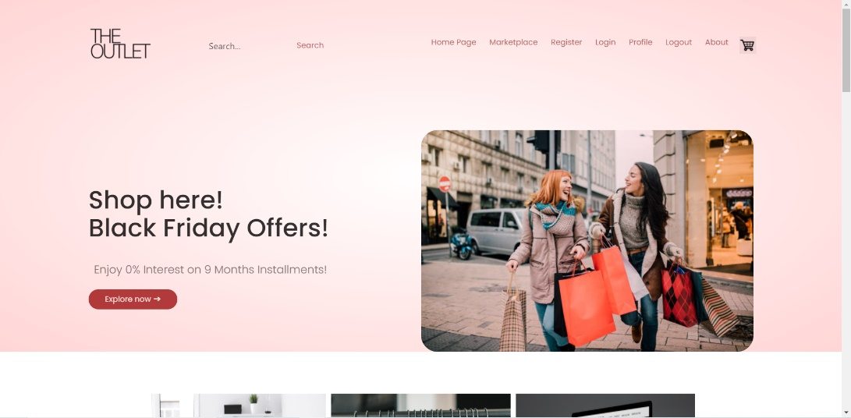A picture containing text, person, indoor

  Description automatically generatedEnd-User Guide:   
   🡺 The User opens the website   
   🡺 This is the home page:   
    
    
    
    
    
    
    
    
     
    
    
    
    
    
    
    
    
    
    
    
    
    
    
    
    
    
    
    
    
    
    
    
    
    
    
    
    
    
    
    
    
    
    
    
    
    
    
    
    
    
    
    
   🡺If you are a new user select Register to create an account in our website:  
  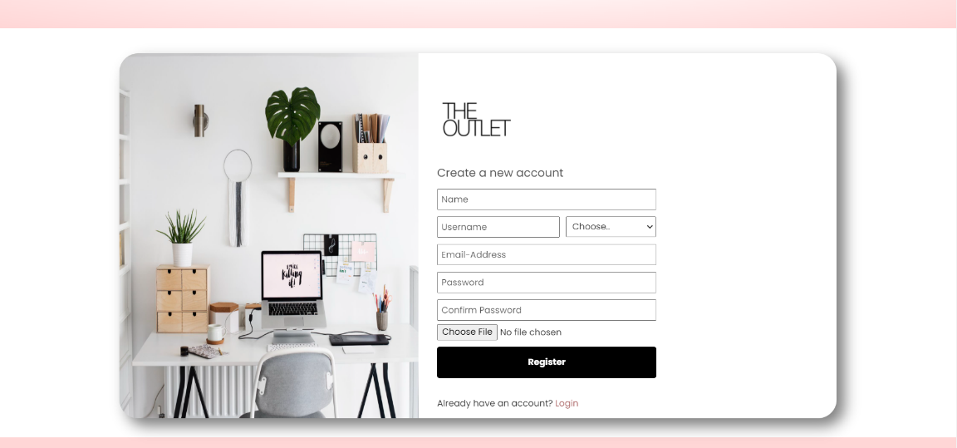  
    
    
    
    
    
    
    
    
    
    
    
    
    
    
    
   🡺If you are already a user select login:  
  Graphical user interface, website

  Description automatically generated  
    
    
    
    
    
    
    
    
    
    
    
    
    
    
    
    
   🡺 When you login this will be your profile page:  
  Text

  Description automatically generated with medium confidence   
    
    
    
    
    
    
     
    
    
    
    
    
    
    
    
    
    
    
    
  Graphical user interface

  Description automatically generated 🡺 If the User wants to change Password he can select change password:  
    
    
    
    
    
    
    
    
    
    
    
    
    
    
  Background pattern

  Description automatically generatedGraphical user interface

  Description automatically generated 🡺When he clicks save button This window will appear for the user:   
    
    
    
    
    
    
    
    
  Graphical user interface, text, application

  Description automatically generatedGraphical user interface

  Description automatically generated 🡺 If the user click Add a new product this form will appear for him to fill it:  
    
    
    
    
    
    
    
    
    
    
    
    
    
  Graphical user interface, application

  Description automatically generatedGraphical user interface

  Description automatically generated 🡺 The user can check his points by clicking on My Wallet :  
    
    
    
    
    
    
    
    
    
    
    
    
    
    
    
    
    
    
   🡺Also the user can add extra points by entering his credit card information.  
   🡺 The user can check all his past orders by clicking on My Orders button:  
  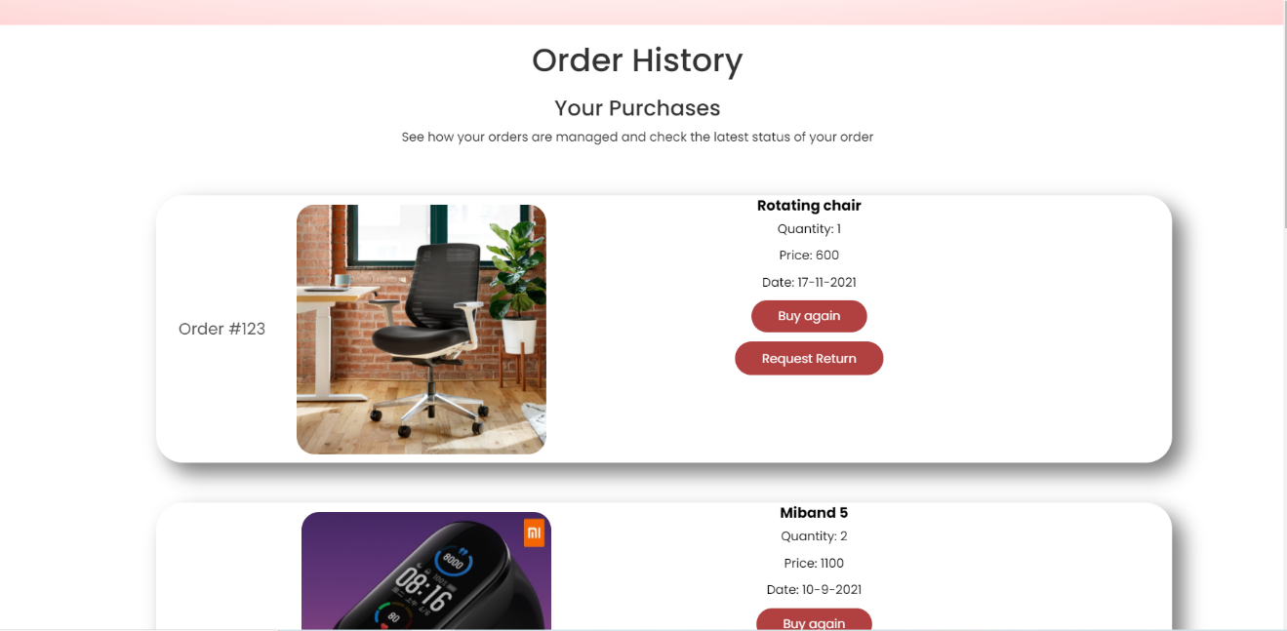  
    
    
    
    
    
    
    
    
    
    
    
    
    
    
    
    
    
   🡺The User can check his products by clicking on My Available products:  
  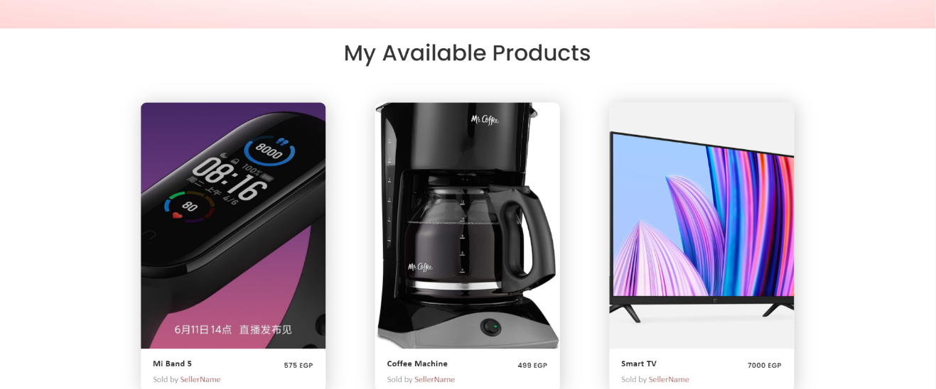  
    
    
    
    
    
    
    
    
    
    
    
    
    
    
  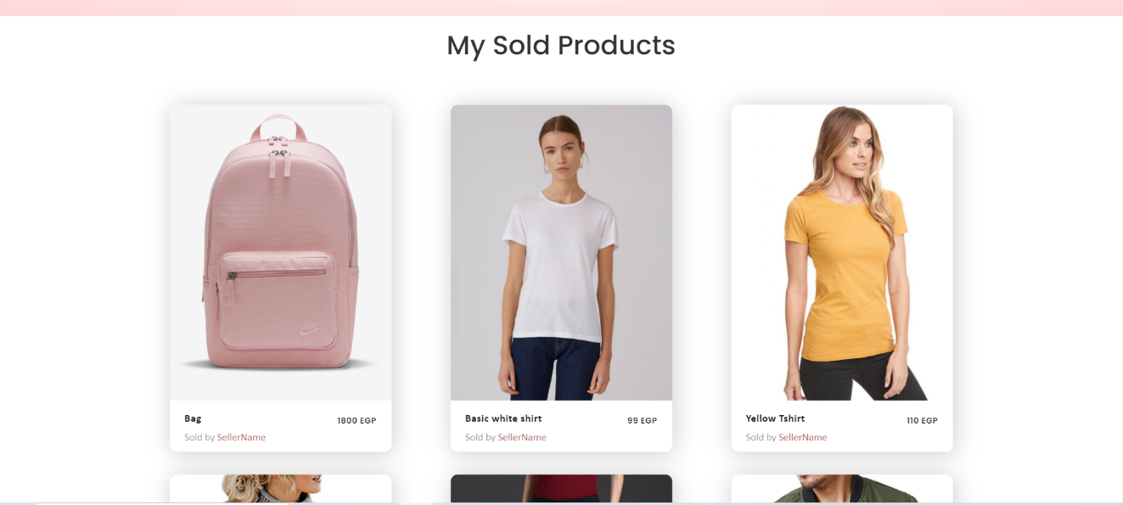 🡺 The User can check his Sold Products by clicking on Sold products:  
    
    
    
    
    
    
    
    
    
    
    
    
    
    
    
    
   🡺The User can pay using his wallet points or using the credit card:  
  A picture containing table

  Description automatically generated  
    
    
    
    
    
    
  Graphical user interface, text, application

  Description automatically generated 🡺Checkout using wallet:  
    
    
    
    
    
    
    
    
    
    
    
    
    
    
     
    
    
    
    
   🡺 Checkout using Credit card:  
    
    
    
    
    
    
    
    
    
  Graphical user interface, application

  Description automatically generated  
    
    
    
    
    
    
    
    
    
    
    
    
    
    
    
   🡺If the user wants to know more about us he can check the About section:  
  Text

  Description automatically generated
* Resources Needed:   
   🡺 Visual Studio Code

|  |  |
| --- | --- |
| Student Name: | Work Done: |
| Ahmed Elsayed | Frontend |
| Ahmed Khaled | Backend + Documentation |
| Mariam Muhammed Alaa | Frontend + Documentation |
| Hagar Waleed Soliman | Backend + Database |
| Hadeer Ahmed | Backend + Database |
| Yasmine Abdelaziz | Frontend + Documentation |

* Role of Each member:
* Appendices:
* References:   
   🡺 <https://www.w3schools.com/html/>   
   🡺 [https://www.w3schools.com/css/default .asp](https://www.w3schools.com/css/default%20.asp)   
   🡺 <https://laracasts.com/series/laravel-6-from-scratch/episodes/58>